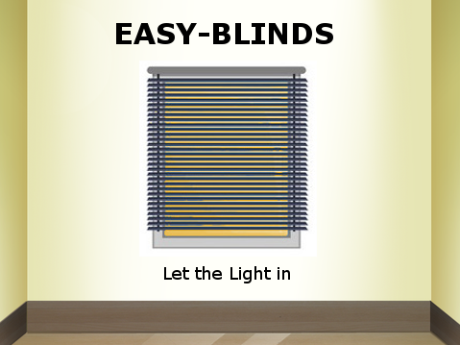

**Project Proposal**

Ashraf Drieas

Brandon Fins

Gabriel Almeida

Juan Inzunza

Mandy Ledford

**Background**

Easy-Blinds manufactures an automatic blinds system designed to optimize the usage of natural lighting and enhance home automation through wifi communication. Many people keep their blinds shut all day and light their homes and offices with other sources. Easy-Blinds fully automates the blinds setup in any space and optimizes the usage of natural lighting.

The Easy-Blinds system is designed for anyone who desires to have an automated home and save on energy costs. The easy-to-use design allows for any home or business owner to easily control their blinds without difficulty. Complex technology lessens the appeal of a product to a large portion of consumers. Easy-Blinds avoids this issue with its easy and intuitive design. This is accomplished through the use of several sensors and wifi communication.

There are three main sensors used to automate the Easy-Blinds system: a light sensor, a motion sensor, and a temperature sensor. The light sensor allows for automation detection of sunrise and sunset. The system can be easily switched to an automatic state in which the blinds open upon detection of sunrise and close upon detection of sunset. The light sensing technology is the basis of the natural lighting optimization that makes the Easy-Blinds system so appealing. The motion sensor allows for the blinds to be open or closed with the simple wave of a hand across the top of the blinds. Lastly the temperature sensor allows for the automatic closing of the blinds when the temperature coming through the window is higher than a user specified temperature. This allows for the user to keep too much heat from entering their home through the window.

Wifi communication is used to connect and control the Easy-Blinds system through an android phone APP and voice communication with the Amazon Echo. The android App can be used to control the light and temperature sensitivity of the system, view the current temperature reading of the system, change the current state of the system to auto (controlled by light and temperature sensor) or manual (manually opened and closed by user), and turn the system on or off. Through voice communication with the Amazon Echo, the blinds can be opened and closed with a simple voice command.

Several products on the market are similar to the Easy-Blinds. One such product is MySmartBlinds. MySmartBlinds feature sun-tracking, bluetooth connection, a schedule setter, an energy savings mode, and battery updates. MySmartBlinds have a retail cost of over $200. Easy-Blinds will be able to offer similar capabilities at a much lower price point. Easy-Blinds can be manufactured at a cost of approximately $50. Easy-Blinds allow any consumer to automate their home and cut down on energy costs at an affordable price.

**The Design:** Following is a functional description of the design.

* The design must be completed and the prototype delivered in 8 weeks.
* The manufactured cost must be less than $100.
* The system must be built upon the Raspberry Pi platform.
* The hardware must include 3 sensors: motion sensor, light sensor, temperature sensor, and a wifi module.
* The motion sensor should be able to open and close the blinds with the wave of a hand across the top of the blinds. It should not be sensitive enough to detect objects that are more than approximately 5 inches away.
* The light sensor will take in current and up to date light intensity readings which will be configured to open at sunset and close at sunrise. Any light reading passing these preset threshold readings will activate the blinds to open/close.
* The temperature sensor should read in temperature values with a percentage error of +/- 1%, the blinds should close in the temperature reading goes above the threshold value.
* The wifi module should be capable of connecting to both and an android App and Amazon Alexa Echo Dot
* The Android App should include 8 inputs and 1 output.
  1. Inputs
     + Temperature threshold: This value controls the temperature threshold value, if the temperature goes above this value the blinds should close.
     + Light Intensity threshold: This value controls the light intensity value, if the intensity is above this value the blinds should open, and if the intensity is below this value the blinds should close.
     + Auto Button: This button switches the system into the AUTO state in which the blinds are fully controlled by the light intensity and temperature values.
     + Manual Button: This button switches the system into the MANUAL state in which the blinds are fully controlled by the user inputs.
     + Open Button: This button opens the blinds.
     + Close Button: This button closes the blinds.
     + On Button: This button turns the system on.
     + Off Button: This button turns the system off.
  2. Output
     + Temperature Display
* The Amazon Alexa Echo Dot will be used to for voice communication between the user and Raspberry Pi. Upon saying “let the light in”, and after verbal confirmation by the Echo Dot, the blinds will open and Alexa will confirm this by letting the user know the state of the blinds.
* The blinds should be opened and closed with a simple servo. The servo should turn the blinds about 90 degrees from the fully closed state to the fully open state, vise versa.

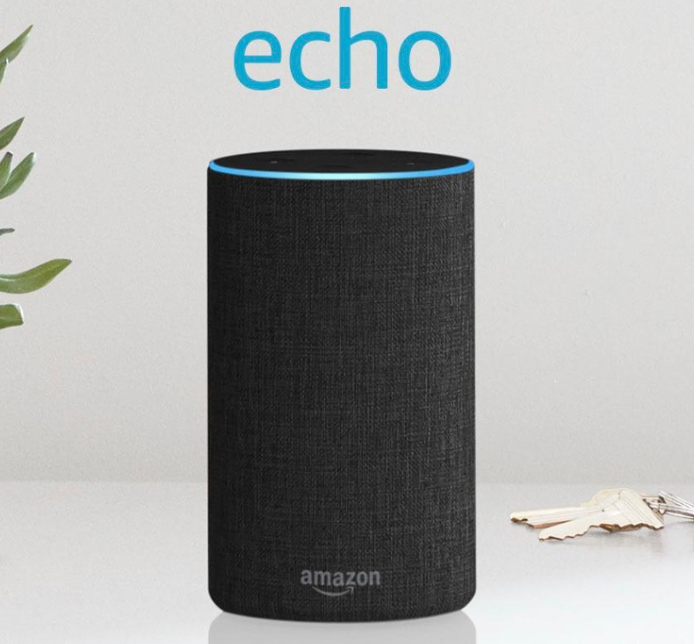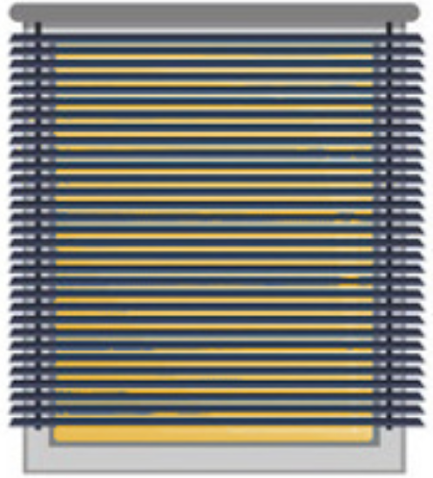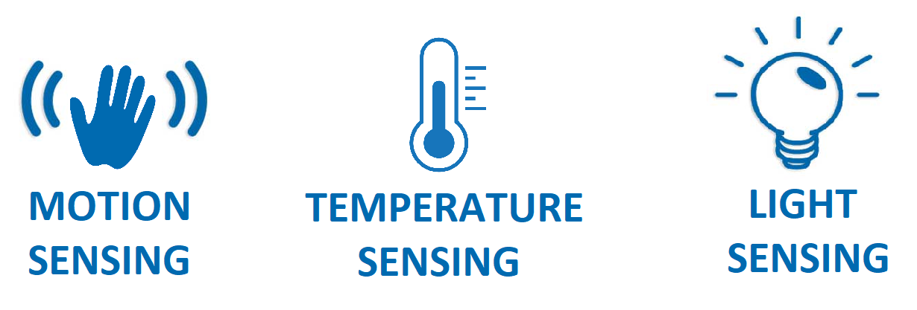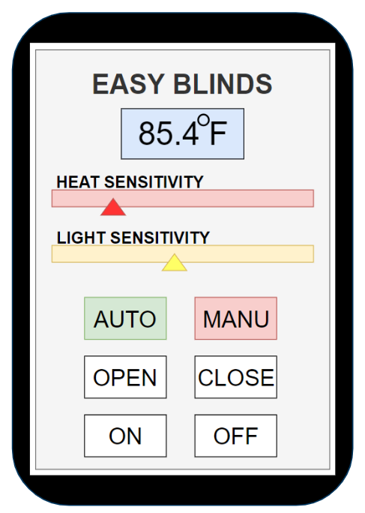

**Deliverables of the Easy-Blind system:**

The main objective of the Easy-Blinds system is to design and implement a fully automated blinds system for any space. The current market does not contain any automated blinds systems with functionality of the Easy-Blinds system. The Easy-Blinds product will become the new industry standard for blinds control capabilities

Within the next 8 weeks the Easy-Blinds team will deliver a fully integrated prototype of the Easy-blinds system. The timeline for the design and implementation of this prototype is as follows:

* Weeks 1-2 : Setup communication between the raspberry pi and a simple android app and the Amazon Echo.
* Weeks 2-4 : Design the android App interface and control the Easy-Blinds system with it
* Weeks 4-6: Control the Easy-Blinds system with the Amazon Echo.
* Weeks 6-8: Configure, test, and debug the system.

At the end of these 8 weeks the Easy-Blinds team will have at least three deliverables. The first being the fully integrated hardware of the system, blinds included. This should be an easy to set up system for the user as all parts are to be encapsulated in the top of the blinds. The second being a downloadable android App which, with easy wifi setup is able to control the Easy-Blinds system. Lastly the team will deliver an easy to follow user manual to guide the user is a quick and painless setup of their new Easy-Blinds system.